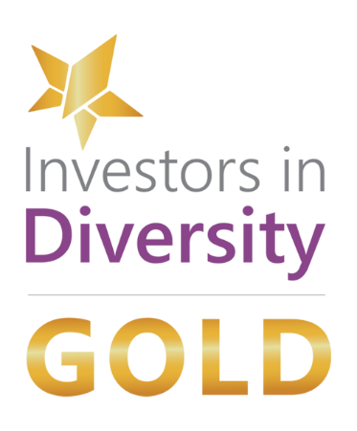
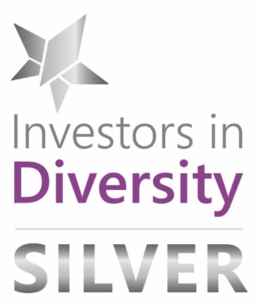
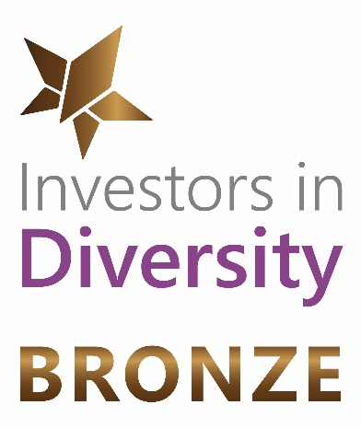


Embrace Inclusion and build Diversity for a future where everyone benefits
As a Diversity & Inclusion (D&I) focused organisation, the Irish Centre for Diversity has a clear understanding of the strategic needs of an organisation that wishes to demonstrate its commitment to this valuable area.
We want organisations to do more than just tick boxes; we want them to transform the workplace environment to one, which is more Equitable and Inclusive. We use cutting-edge tools and services to measure and inform organisations about workplace culture through the lens of FREDIE™ (Fairness | Respect | Equality | Diversity | Inclusion | Engagement).

“Achieving Investors in Diversity Gold is a massive milestone for us. The Construction Industry can often be seen as a tough, predominantly male environment, which can present barriers in the DE&I space. Achieving Gold accreditation demonstrates that meaningful progress is possible, even with challenges. The accreditation process helped us identify areas for improvement through a robust action plan, while embedding DE&I into our workplace in a way that feels authentic and sustainable.”
– PJ Hegarty & Sons
INVESTORS IN DIVERSITY ACCREDITATION
- Over 320 organisations are on the Investors in Diversity Journey
- 107% increase in organisations undertaking IiD Gold 2025 vs 2024
- More than 40 organisations have now achieved IiD Gold Status

Over 450 organisations have engaged in the Investors in Diversity process to date.
These include:
AIB | A&L Goodbody | Aldi | Aon | The Arts Council | Aviva | Bank of Ireland | Bord Gáis Energy | Catalyx | CBRE | Clúid | CORE | Cpl | DBFL Consulting Engineers | emeis | Expleo | FBD Insurance | Fidelity Investments | Forvis Mazars | Glenveagh | Grant Thornton | PJ Hegarty & Sons | Hostelworld | IDA Ireland | Ipsen | Irish rugby Football Union (IRFU) | Jones Lang Lasalle (JLL) | Laya Healthcare | Matheson LLP | Nestlé | Nicholas O’Dwyer | The National Lottery | PTSB | Roayl Colleage of Physicians of Ireland | Sisk | SOLAS | Sun Life | Three | Weltec Engineering | Woodie’s & more

INVESTORS IN DIVERSITY FRAMEWORK
Ireland’s leading D&I framework and accreditation offers organisations a clear and structured pathway to transform Diversity, Inclusion & Culture.
This includes focuses on:
- Diverse & Inclusive Leadership
- Policies, Practice & Process
- Recruitment, Retention & Progression
- Recording & Monitoring
- Impact on external Diversity

THE JOURNEY



Investors in Diversity Bronze focuses on Committing - Establishing a strong D&I foundation
The process includes:
- Review people policies with D&I lens. Feedback on areas for development
- Review effective communication of policies across organisation
- Train senior leaders in D&I


Investors in Diversity Silver focuses on Embedding - Measuring the culture of your organisation with a D&I lens
The process includes:
- An all-employee survey to understand the lived experience
- Mapping data against ICFD maturity model
- Benchmarking against national and sector data sets
- ICFD develop a D&I action plan based on findings



Investors in Diversity Gold focuses on Leading - Making D&I part of the DNA of your organisation
The process includes:
- Organisations undergo an in-depth self-assessment application against ICFD’s five pillars of excellence
- Assessments are reviewed by ICFD experts, providing recommendations for continued improvement and D&I excellence to maintain leadership

WHAT OUR CLIENTS SAY

“Retaining Investors in Diversity Gold is extremely important to us, as it reaffirms the progress we have made and reinforces the commitments outlined in our 2024-2025 strategy. It validates that we have created an Inclusive Culture and are committed to building on this in the years ahead.

The accreditation is also a significant accolade as a supplier, enabling us to work with like-minded organisations who share our approach. It reinforces our DEI ethos both as an employer and as a Talent Solutions Provider.” – Cpl

“Achieving Investors in Diversity Silver reflects the importance we place on Equality, Diversity & Inclusion. The Royal College of Physicians of Ireland is committed to creating an environment where every Diversity is celebrated, and everyone is treated fairly. The accreditation recognises our efforts to date, and we continue to build upon this work. ED&I is not a short-term initiative, but a long-term priority embedded within our corporate strategy.” – Royal College of Physicians of Ireland

“We are very proud to have achieved Investors in Diversity Silver.
A diverse workforce benefits both employees and the organisation, bringing different perspectives and approaches that foster innovation, creativity, and stronger engagement.
This creates an environment that supports improved performance, stronger retention and enhances our brand reputation as an inclusive employer.” – Weltec Engineering

“Achieving Investors in Diversity Silver accreditation is a significant milestone for the Bons Secours Health System. This recognition reinforces our ongoing commitment to fostering an Inclusive & Diverse workplace where everyone feels comfortable being themselves and is supported to reach their full potential. We are proud of this achievement and committed to building on it as we continue our Investors in Diversity journey.” – Bon Secours Health System

“Achieving the Investors in Diversity Bronze accreditation reflects our dedication to creating a more inclusive and welcoming environment for our staff. It recognises the efforts of our EDI Committee, established in September 2024, in championing Diversity & Inclusion across Education and Training Boards Ireland. Their commitment and leadership have been instrumental in progressing our EDI initiatives and achieving this important recognition.” – Education & Training Boards Ireland (ETBI)

BENCHMARKING YOUR PROGRESS
The Irish Centre for Diversity are in a unique position to be able to benchmark the data gathered on behalf of its clients against organisations across Ireland and within specific sectors. The ICFD can measure the D&I performance and culture of an organisation and provide a roadmap of improvement.

ROBUST, RELIABLE & VALID
- Our survey data is based on results from 190+ organisations employing over 150,000 employees in Ireland
- Our D&I culture metrics are regularly analysed for reliability and validity
- The data is updated every 12 months
- Our benchmarks are based on the average calculation across all survey responses

INCLUSION SCORE - BENCHMARKING YOUR ORGANISATION
From the data gathered through the survey, the ICFD will calculate your Inclusion Score which will be a measure of how ‘included’ your staff feel.
The benchmark Inclusion Score will be presented in a bar chart with comparisons against the Sector and National benchmarks.

- 14.5% - Highest increase to date on Inclusion Score when implementing and reaccrediting IiD
- D&I perceptions and experiences IMPROVE by an average of 8-10%

Join us in setting the standard for D&I culture in Ireland’s workplaces. Working with us, unlocks the potential for positive change within your organisation.

To find out what your organisation inclusion score is, email us at enquiries@ICFD.ie
CONSULTANCY & SUPPORT
Our team of highly-trained and experienced consultants has provided over 100 organisations in Ireland with guidance, facilitation and advice on matters relating to Diversity & Inclusion. We regularly support clients across a range of requirements including:

Strategy & Action Planning Workshops | ERG Establishment |
Bespoke measurement | D&I Policy Development and Reviews | Develop and embed D&I Champion Programmes | D&I Task & Finish Groups to support and track progress | Coaching D&I Engagement and Communication D&I Toolkits | Listening Circles | Recruitment Audits | Culture reviews audits | Setting up Steering Committees and Working Groups

“I cannot recommend the Irish Centre for Diversity highly enough as a D&I partner to the business. The team takes the time to truly understand the business needs and to work as a partner with the business to authentically embed D&I into everything we do for our team and for our customers.” - Laya Healthcare

“We would recommend working with the Irish Centre for Diversity if you are serious about making meaningful improvements to your working environment from a Diversity & Inclusion perspective. What you may lack in expertise, representation, understanding or knowledge, they can help you become aware and fill some of those gaps. They have a wealth of insight and excellent staff who can challenge your thinking in a constructive and helpful way. – National institute for Bioprocessing Research and Training (NIBRT)

For more information on how the Irish Centre for Diversity can support you on your D&I journey visit our website – www.ICFD.ie or email us – enquiries@ICFD.ie

Follow us:
Linkedin - irish-centre-for-diversity
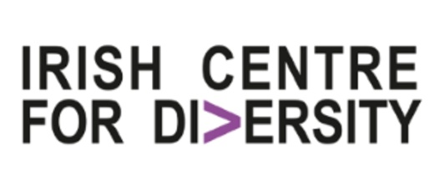
Instagram - irishcentrefordiversity

