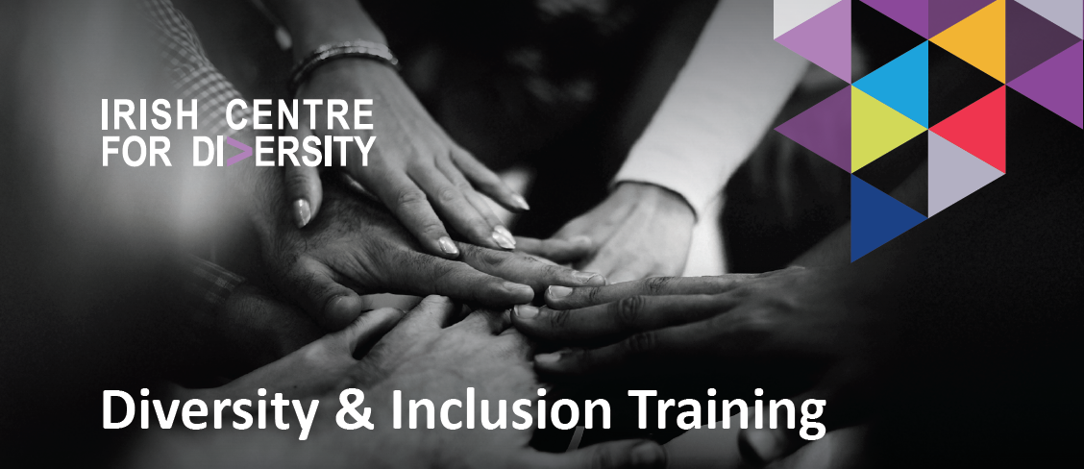
www.ICFD.ie
We are the leading provider of Diversity & Inclusion training with over 25 different courses

“Every facilitator that I've met through the Irish Centre for Diversity has been incredibly knowledgeable, approachable and great to work with. I'd highly recommend them.” - Cpl
“The training was well delivered, and the trainer was very knowledgeable. It was good to relate to examples and scenarios to make the learning stick.” – JJ Rhatigan Building Contractors
“The training we received was really-well rounded and informative. It gave us a lot to think about, work on and improve.” – EirGrid
“Excellent training, ability to relate to audience very well, understanding the needs of the organisation. Very professional.” - Tallaght University Hospital
“The level of training is very high, there is a great understanding of the practicalities of implementing inclusion and diversity in the workplace.” – Engineers Ireland

Introduction
An important aspect of building an Inclusive work environment is ensuring everybody has the knowledge and awareness they need to foster a supportive culture where everyone can thrive. Our team of highly-experienced trainers from diverse backgrounds bring a unique approach to the delivery of our engaging training courses. In addition to our training courses, we also build bespoke packages to address an organisation’s specific needs.

Our Mission
We want organisations to do more than just tick boxes; we want them to transform the workplace environment to one which is Equitable & Inclusive.
- We have designed and delivered more than 2,560 EDI training sessions to over 51,200 individuals
- We are delivering our services to over 600 businesses across Ireland
- We have a team of over 30 diverse and knowledgeable people
- 98.90% positive client ratings
- 98.90% Facilitator excellence
- 99% would recommend
Discover full course overviews and learning outcomes – click here irishcentrefordiversity.ie/training-onsitevirtual/

Training Courses: Virtual & On Site
Discover full course overviews and learning outcomes here – click here irishcentrefordiversity.ie/training-onsitevirtual/
- Inclusive Leadership
- Unconscious Bias
- Inclusive Language Introduction to Diversity & Inclusion
- Inclusive Recruitment Psychological Safety
- Allyship Active Bystanding
- Cultural Awareness Diversity & Inclusion Masterclass
- Mental Health in the Workplace
- Creating a Culture of Dignity and Respect in the Workplace
- Gender Equality /Gender Matters
- Disability in the Workplace
- Race Awareness
- LGBTQ+ Awareness / LGBTQ+ Inclusion in the Workplace
- Neurodiversity
- Mental Health in the Workplace - Depression and Anxiety
- Mental Health in the Workplace - Burnout
- Mental Health in the Workplace – Addiction
- D&I Champion Programme

eLearning Courses
- FREDIE – The Basics (Fairness | Respect | Equality | Diversity | Inclusion | Engagement)
- Unconscious Bias
- Race Awareness
- LGBTQ+ Awareness

For more information on how the Irish Centre for Diversity can support you on your D&I journey visit our website – www.ICFD.ie or email us – enquiries@ICFD.ie

Follow us:
Linkedin - irish-centre-for-diversity
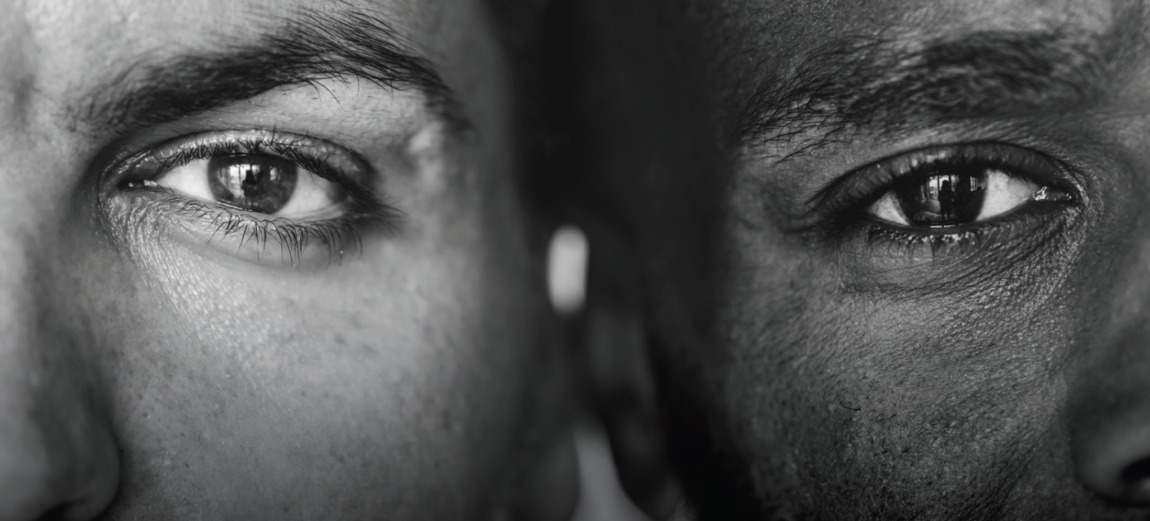
Instagram - irishcentrefordiversity

