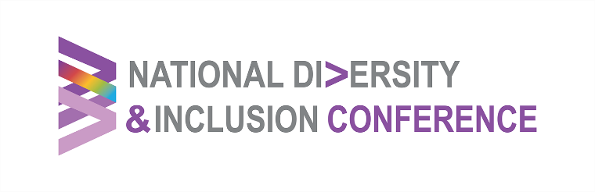
Wed 2 Sept 2026 |The Gibson Hotel, Point Square, Dublin 1
AGENDA
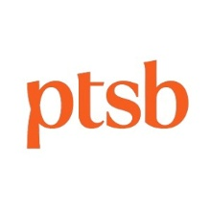
Primary Sponsor - PTSB
8.00-8.45am Registration & Networking Breakfast
8.45-9.00am Welcome & Opening Remarks
Solat Chaudhry Irish Centre for Diversity
9.00-9.20am Keynote: Leading from Lived Experience - Breaking barriers, Belonging & Allyship
Councillor Yemi Adenuga Meath County Council
9.20-10.05am Panel Discussion: A Public Sector/Civil Service That Works Better The Role of Inclusive Workforces
How Inclusive leadership, culture and workforce practices strengthen public service delivery, decision-making and outcomes across the system
Aideen Murphy NTMA | Sharon Doyle BnM | Siobhán McKenna Dept of Public Expenditure NFD Delivery & Reform | John Keane St. Vincent's University Hospital
10.05-10.50am Panel Discussion: Breaking Barriers to Work Collaboration, Opportunity & Belonging
Exploring how cross-sector and community collaboration can open pathways to work, address exclusion and support sustained Inclusion & Belonging
Edima Inyang African Professional Network of Ireland (APNI) | Jeanne McDonagh Open Doors Initiative | Kerrie Leonard Irish Paralympian |Michael Reilly Longford County Council
10.50-11.20am MORNING BREAK
11.20-11.40am Panel Discussion: Building Ireland’s Infrastructure The role of Culture, Inclusion & Belonging
How an Inclusive workforce, safe workplace culture & strong leadership are connected and essential to delivering housing & critical infrastructure
Jan Glynn PJ Hegarty & Sons | Susan Carroll Cairn Homes plc | Andrew Brownlee Construction Industry Federation (CIF) | Danny Pio Murphy DBFL Consulting Engineers
12.25-12.45pm Closing Reflections
Karen Hackett PTSB
12.45-1pm Wrap & End
Claire Brock MC

