IRISH CENTRE FOR DIVERSITY

Investors in Diversity (IiD) Accreditation Framework


Document | Investors in Diversity Accreditation Framework
Published By | Irish Centre for Diversity (ICFD)
Version | 1
Publication Date | September 2026
Next Review Date | September 2027

Contents
Part A: Accreditation Framework 4
1. Purpose and principles 4
1.1 Purpose of the accreditation 4
1.2 Eligibility and Access 4
1.3 Fees 5
2. History and Development of the Framework 5
2.1 Framework Principles 6
3. Accreditation structure 6
3.1 Accreditation Criteria 7
3.2 Assessment approach 7
3.3 Investors in Diversity Pillars 8
3.4 Bronze Assessment – Committing 9
3.5 Silver Assessment – Embedding 9
3.5.1 Benchmarking and Inclusion Score 10
3.5.2 Accreditation is dependent upon: 11
3.6 Gold Assessment – Leading 11
3.6.1 Assessment Methodology 12
3.6.2 Gold Assessment Criteria 12
3.6.3 Gold Decision-Making 13
4. Governance, independence and decision-making 13
4.1 Governance Structure 13
4.2 Independence and Impartiality 14
4.3 Conflict of Interest 14
4.4 Assessment and Verification Controls 14
4.5 Decision-Making 15
4.6 Records and Accountability 15
5. Accreditation outcomes 15
5.1 Accreditation Awarded 15
5.1.1 Consistency Controls 15
5.2 Additional Information or Evidence 16
5.3 Accreditation outcomes pathways 16
5.4 Maintenance of Accreditation 17
6. Reassessment and monitoring 17
6.1 Reassessment Overview 17
6.2 Accreditation Periods 17
6.3 Reassessment Timelines 17
6.4 Reassessment Requirements 18
6.4.1 Bronze 18
6.4.2 Silver 18
6.4.3 Gold 18
6.5 Progression Through Accreditation Levels 19
6.6 Monitoring and Record Keeping 19
6.7 Ongoing Accreditation Monitoring 19
7. Complaints and appeals 20
7.1 Complaints 20
7.2 Appeals 20
7.3 Review and Decision-Making 20
7.4 Timescales and Communication 21
7.5 Records and Continuous Improvement 21
8. Contact Details 22
8.1 Supporting Methodologies and Procedures 22
Part B – Accreditation Roadmap 23
Bronze Roadmap 23
Silver Roadmap 23
Gold Roadmap 24
Part C 3-year Example Accreditation Journey 25
Illustrative three-year month-by-month timeline 25

Part A: Accreditation Framework

1. Purpose and principles

1.1 Purpose of the accreditation

Investors in Diversity (IiD) is Ireland's premier Diversity & Inclusion accreditation framework. It provides organisations with a structured pathway to embed FREDIE™ (Fairness, Respect, Equality, Diversity, Inclusion and Engagement) into workplace
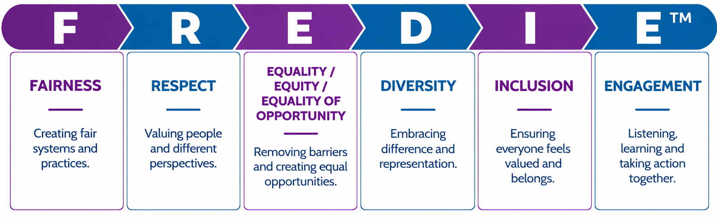
culture, leadership, policies, processes and decision-making. The accreditation supports organisations to assess their current position, identify opportunities for improvement and demonstrate continuous progress.

Image 1: FREDIE

1.2 Eligibility and Access

The Investors in Diversity (IiD) accreditation framework is open to organisations of all sizes, sectors and organisational structures. Organisations seeking accreditation must complete the relevant application and assessment process and provide evidence demonstrating their performance against the published accreditation criteria.
ICFD is committed to providing fair, transparent and non-discriminatory access to accreditation. All organisations are assessed against the same published standards, requirements and assessment methodology appropriate to the accreditation level being sought.

Information relating to accreditation levels, assessment requirements, processes,
timelines and accreditation fees is provided to organisations before they commence the accreditation process.

1.3 Fees

Accreditation fees are determined according to organisational size, based on employee numbers, and vary depending on the accreditation level being undertaken (Bronze, Silver or Gold).
ICFD operates a tiered pricing structure to ensure that accreditation remains accessible and proportionate for organisations of different sizes. Details of applicable fees, assessment requirements, timelines and process steps are provided to organisations before they commit to or commence the accreditation process. This ensures that organisations have clear and transparent information regarding costs and participation requirements before applying for accreditation.

2. History and Development of the Framework

The Investors in Diversity Framework was developed in 2018 using evidence-based assessment principles, employee experience measurement, organisational maturity modelling and Irish equality legislation.
Since its introduction, the framework has continued to evolve through stakeholder engagement, assessor feedback, client experience, operational learning and periodic review activities. The framework has been informed by accredited organisations, diversity and inclusion practitioners, assessors, subject matter experts and other contributors with relevant expertise and experience.
While some historic consultation records from the original 2018 framework development are no longer readily available, ICFD has documented the history and evolution of the Investors in Diversity Framework and maintains a Stakeholder Consultation Log to record stakeholder engagement, feedback and resulting changes. Where historic records can be located, they are being added to the log to provide additional evidence of expert and stakeholder involvement in the development and ongoing improvement of the framework.
Further information is available on request.

2.1 Framework Principles
The framework is built on the following core principles:
Evidence Based Assessment
Leadership Commitment
Employee Voice
Continuous Improvement
FREDIE
Irish Legislation

Figure 1: Framework Principles

3. Accreditation structure

Investors in Diversity comprises three progressive accreditation levels that support organisations at different stages of their diversity and inclusion journey:
- Bronze (Committing): focuses on leadership commitment, governance, policies and training.
- Silver (Embedding): focuses on employee experience, inclusion, organisational culture and action planning.
- Gold (Leading): focuses on strategic integration, accountability, monitoring and organisational impact.
Together, these levels provide a structured pathway from commitment to embedding and leading practice.

Level |  | Committing | D&I related policies, leadership commitment and governance
Purpose |  | Embedding | Employee voice, culture measurement, demographic understanding and action planning
Focus Areas |  | Leading | Strategic integration, accountability, monitoring, recruitment, progression and external impact
Table 1: Framework Structure

3.1 Accreditation Criteria

Organisations are assessed against published Investors in Diversity accreditation criteria aligned to the accreditation level being sought. Assessment criteria are based on the Investors in Diversity framework, Maturity Model and supporting guidance documents. Depending on the accreditation level, assessments may consider policies, governance arrangements, employee experience, survey outcomes, evidence submissions, interviews, monitoring arrangements and performance across the Investors in Diversity pillars.

3.2 Assessment approach
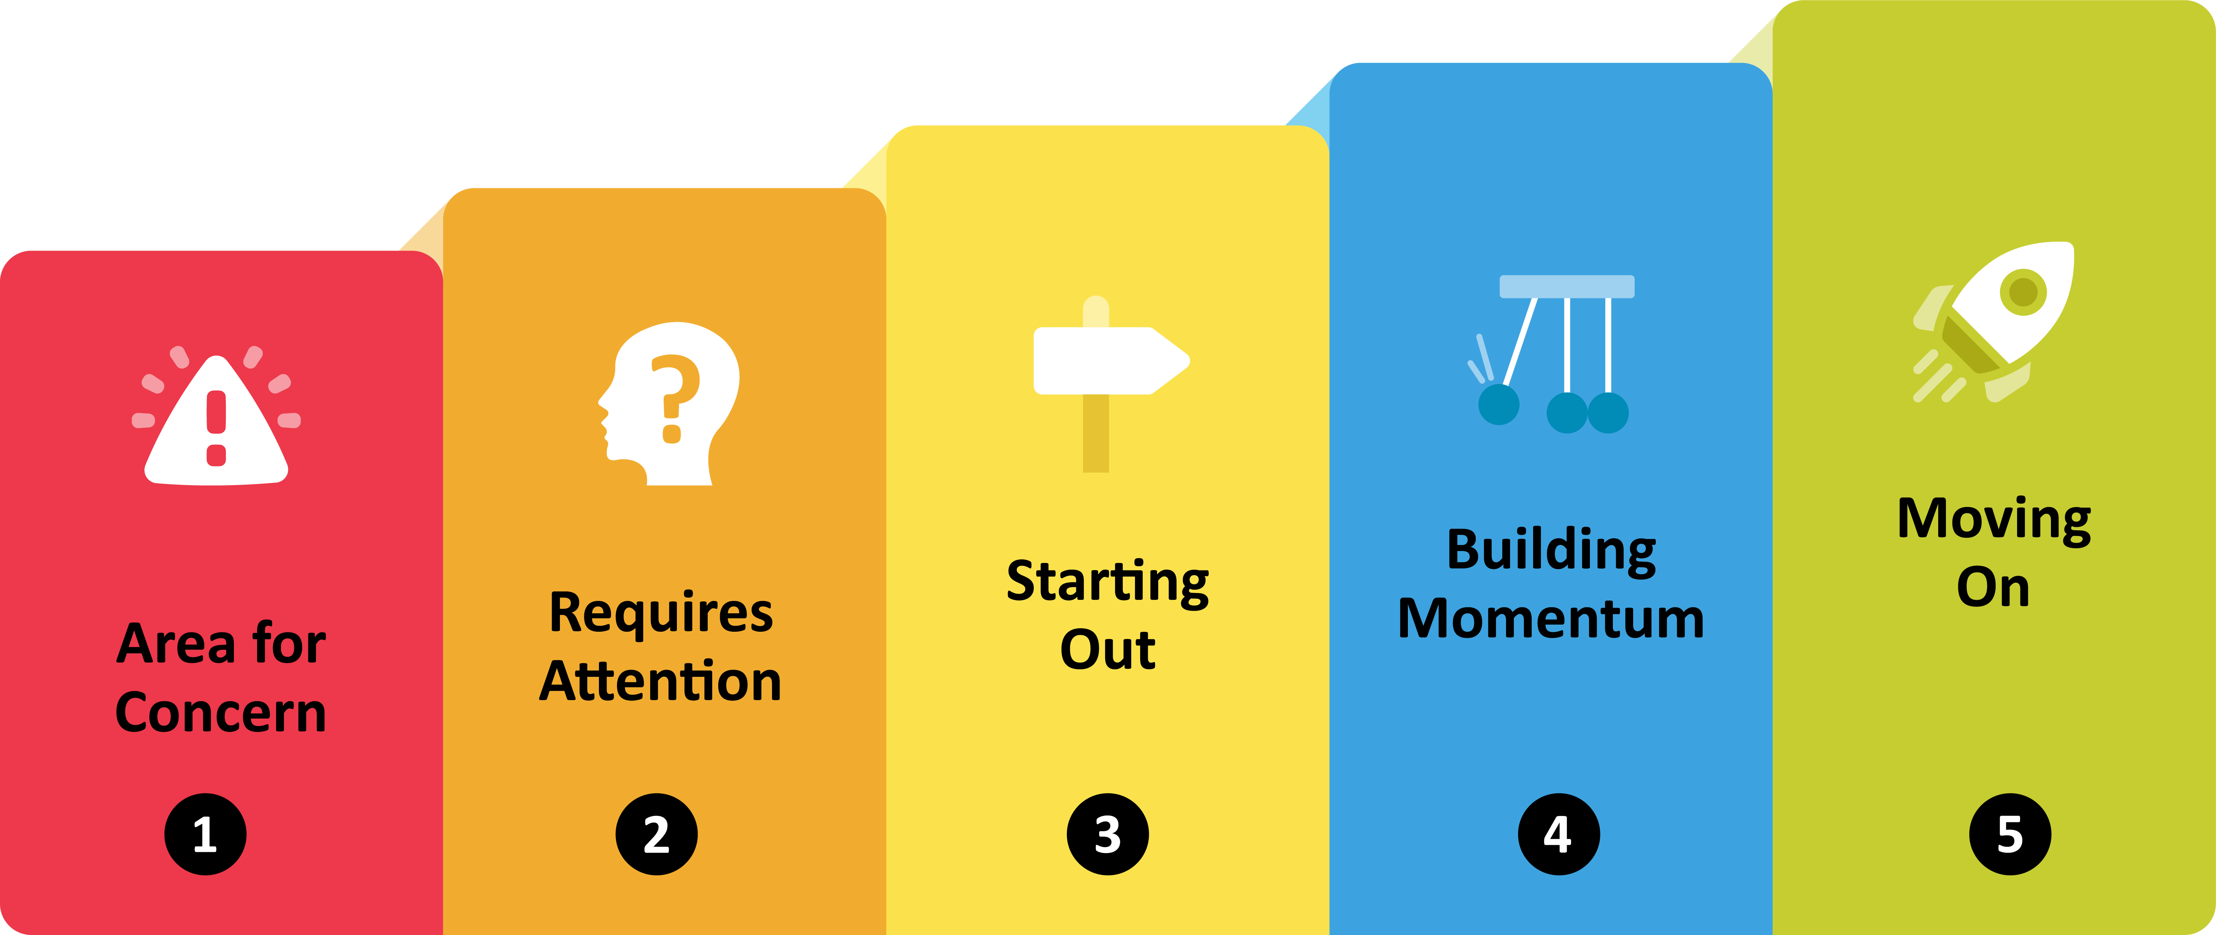
The Maturity Model forms the basis of assessment across the Investors in Diversity framework and supports consistent evaluation of organisational performance and progress.

Image 2: Investors in Diversity Maturity Model

Area for Concern: Significant improvement required before accreditation can be achieved
Requires Attention: Below accreditation standard and further development required
Starting Out: Foundation level of maturity achieved
Building Momentum: Good level of maturity with evidence of progress and embedding
Moving On: Strong evidence of maturity and leading practice
The Maturity Model forms the basis of assessment across the Investors in Diversity framework and supports consistent evaluation of organisational performance and progress.

3.3 Investors in Diversity Pillars

The Investors in Diversity framework is built around five pillars that collectively assess how diversity and inclusion are embedded across an organisation. The pillars provide the structure for assessment activities and support organisations to identify strengths, areas for development and opportunities for continuous improvement.
The pillars are used to assess how Diversity and Inclusion is reflected across leadership, policies, workforce practices, data and external impact. They are particularly important at Gold level, where organisations are expected to demonstrate evidence across all five areas.

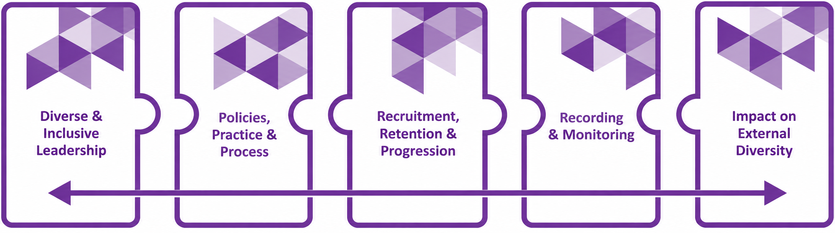

Image 3: Investors in Diversity Pillars

3.4 Bronze Assessment – Committing

Bronze focuses on establishing the foundations for Diversity and Inclusion and embedding FREDIE within organisational systems. Accreditation is based on a review of the organisation's policies, training and policy embedding activities.
Bronze scoring is based on a points-based methodology set out within the Bronze Guidance.
Organisations that successfully meet the Bronze standard are awarded Investors in Diversity Bronze accreditation. Bronze accreditation is valid for 12 months from the date of the Bronze report.

Key Requirements

Bronze Decision-Making

Assessment Methodology
- Ensure all senior leaders complete Inclusive Leadership training delivered by the Irish Centre for Diversity.
- Demonstrate at least two methods of embedding Diversity and Inclusion policies within the organisation.
- Submit the required mandatory policies and minimum number of policies appropriate to organisational size
- Review of submitted policies and supporting documentation
- Evaluation of policy quality, breadth and review cycles.
- Review of Diversity and Inclusion training undertaken by senior leaders and staff.
- Assessment of policy embedding activities and evidence.

- Policy review scores
- Policy review dates
- Diversity and Inclusion training activity
- Policy embedding methods
- Additional Diversity and Inclusion policies submitted

Figure 2: Bronze Assessment

3.5 Silver Assessment – Embedding
Silver focuses on understanding organisational culture through the lived experiences of employees and measuring inclusion across the organisation.

Key Requirements

Silver Decision-Making

Assessment Methodology
- Commitment to an organisation-wide employee survey.
- Achieve sufficient employee participation to enable meaningful analysis and statistical validation.
- Support the promotion and communication of the survey to employees.

- Organisation-wide employee survey administered by ICFD
- Statistical validation of responses.
- Maturity Model scoring.
- Benchmarking against national and sector datasets.
- Analysis across the first four Investors in Diversity pillars.

- Individual survey questions are scored and aggregated to produce pillar scores and an overall organisational outcome.
- Detailed scoring thresholds are maintained within the Silver Assessment Guidance.

Figure 2: Silver Assessment

Organisations also receive an Inclusion Score, which provides an overall measure of how included employees feel within the organisation. The Inclusion Score may be presented alongside national and sector benchmark comparisons to support interpretation of survey findings, identify strengths and inform action planning.

3.5.1 Benchmarking and Inclusion Score
The Investors in Diversity benchmarking process provides organisations with additional context regarding their Diversity and Inclusion survey results.
Survey findings may be compared against national and sector benchmark datasets maintained by the Irish Centre for Diversity. Benchmarking supports interpretation of survey findings and helps organisations identify strengths, opportunities and areas for further development. Benchmarking can be presented in a number of formats, including tables, such as this (Table 2):

 | Pillar 1  Diverse & Inclusive Leadership | Pillar 2  Policy, Practice, and Process | Pillar 3  Recruitment, Retention, and Progression | Pillar 4  Recording and Monitoring
Your Organisation | XX% | XX% | XX% | XX%
Your Sector Benchmark (if available) | XX% | XX% | XX% | XX%
National Benchmark | XX% | XX% | XX% | XX%
Table 2: Example comparison of Organisation, Sector & National Benchmark scores across the four Investors in Diversity pillars.
Benchmarking and Inclusion Scores are provided for information and continuous improvement purposes. They do not directly determine accreditation outcomes, maturity ratings or assessment scores.

3.5.2 Accreditation is dependent upon:
- Achieving the minimum positive response thresholds defined within the methodology.
- Meeting the required standards of statistical validity.
- Avoiding disqualifying outcomes for inappropriate behaviour questions.
Organisations achieving the required accreditation standard are awarded Investors in Diversity Silver accreditation.
Silver accreditation is valid for two years for organisations achieving Building Momentum or Moving On. Organisations achieving Starting Out receive accreditation subject to the conditions set out within the Silver framework.

3.6 Gold Assessment – Leading
Gold assesses how effectively Diversity and Inclusion has been embedded throughout the organisation's strategy, culture, governance and operational practices.

3.6.1 Assessment Methodology
The Gold assessment consists of two elements:
- Survey assessment.
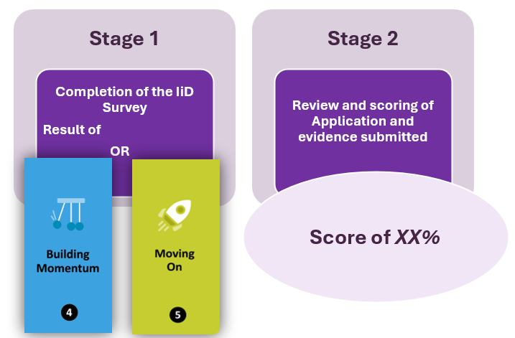
- Review of application responses and supporting evidence.

Image 4: Gold Stages
The survey element may be satisfied through either:
- A valid Investors in Diversity Silver survey outcome of either “Building Momentum” or “Moving On” within the required assessment period; or
- Completion of a new survey as part of the Gold assessment process.
The survey component is assessed using the same Maturity Model methodology applied at Silver level.

3.6.2 Gold Assessment Criteria
Gold evidence is assessed against the five Investors in Diversity pillars:
- Diverse and Inclusive Leadership
- Policy, Practice and Process
- Recruitment, Retention and Progression
- Recording and Monitoring
- Impact on External Diversity

3.6.3 Gold Decision-Making
Gold accreditation decisions are based on:
- Survey outcomes
- Assessment of the application and supporting evidence
- Assessment against the five Investors in Diversity pillars
- Interview findings
- Foundation and Maturity Point scores and
- Achievement of the required scoring thresholds.
Evidence submissions are scored using a combination of:
- Foundation Points and
- Maturity Points
Foundation Points demonstrate that a requirement, process or practice is in place and evidenced. Maturity Points recognise how effectively and impactfully Diversity and Inclusion has been embedded across the organisation.
Organisations must achieve the required Foundation Point thresholds within each pillar and across the assessment overall.
Detailed scoring methodologies and thresholds are maintained within the Gold Guidance.
Organisations achieving the required assessment thresholds are awarded Investors in Diversity Gold accreditation.
Gold accreditation is valid for two years.

4. Governance, independence and decision-making

4.1 Governance Structure
The Irish Centre for Diversity (ICFD) is responsible for the governance, management and oversight of the Investors in Diversity (IiD) accreditation framework, including the assessment process and final accreditation decisions. Assessments are conducted by trained assessors who review evidence against published criteria and assessment guidance. Accreditation decisions remain the responsibility of ICFD.

4.2 Independence and Impartiality
Assessments are evidence-based and informed by documentary submissions, survey findings (where applicable), verification activities and assessor reviews. Assessors follow defined assessment guidance and scoring frameworks to support consistency, fairness and objectivity in decision-making.
In addition, the IiD Advisory Board provides independent advice where appropriate to support the credibility and integrity of the accreditation process. The Advisory Board may provide independent advice on governance matters, framework development, complaints and appeals, and issues relating to independence and impartiality. Advisory Board members do not conduct assessments and do not make accreditation decisions. Final accreditation decisions remain the responsibility of ICFD.

4.3 Conflict of Interest
ICFD is committed to identifying, managing and preventing actual, potential and perceived conflicts of interest that could affect the independence, impartiality or credibility of the accreditation process. Individuals involved in assessment, verification, decision-making, complaints or appeals activities are required to disclose any conflicts of interest and act in accordance with ICFD's Independence, Impartiality and Conflict of Interest Policy.
Individuals who have provided consultancy, advisory support, coaching or accreditation preparation assistance to an organisation are not permitted to assess that organisation. Assessors are also prohibited from reviewing work they have contributed to or participating in appeals relating to assessments in which they were involved.
Where a conflict of interest is identified, ICFD will take appropriate action to safeguard the integrity of the accreditation process, including appointing an alternative assessor or decision-maker where necessary. All conflicts and mitigation actions are documented and retained as part of the accreditation record.

4.4 Assessment and Verification Controls
Assessment and verification activities are governed by the IiD Assessment and Verification Procedure. Assessors and verifiers are selected on the basis of relevant qualifications, experience and demonstrated competence. They must understand the IiD framework and methodology, complete required training, comply with confidentiality and impartiality requirements, and declare actual, potential or perceived conflicts of interest before allocation.
No person may verify their own work or assess or verify an organisation where they have provided relevant advisory, consultancy, training or support services. Where a conflict is identified, an alternative assessor, verifier or reviewer is appointed and the decision is recorded.
Bronze evidence assessments are independently verified against the published minimum requirements. Silver survey reports are independently checked for data accuracy, calculations, participation, validity, benchmarking and consistency of findings. Gold assessments are conducted by an independent assessor and independently verified before an accreditation recommendation proceeds.

4.5 Decision-Making
Accreditation decisions are based on a combination of:
- Evidence reviewed against published criteria
- Survey outcomes (where applicable)
- Interviews and supporting information
- Assessment scoring thresholds
- Assessor findings and recommendations
Where required, independent advice may be sought from the IiD Advisory Board to support fair, consistent and evidence-informed decision-making.

4.6 Records and Accountability
ICFD maintains records relating to assessments, evidence submissions, survey data, declarations, reports and accreditation decisions. Records are retained in accordance with relevant data protection, confidentiality and record-keeping requirements to support transparency, accountability and auditability of the accreditation process.

5. Accreditation outcomes

5.1 Accreditation Awarded
Organisations that demonstrate compliance with the relevant accreditation requirements and achieve the applicable assessment thresholds may be awarded Bronze, Silver or Gold accreditation. Accreditation outcomes are based on the assessment criteria and evidence requirements for the relevant accreditation level.

5.1.1 Consistency Controls
Consistency is maintained through:
- Published guidance
- Standardised scoring approaches
- Verification processes
- Assessor review procedures
- Evidence requirements

5.2 Additional Information or Evidence
During the assessment process, assessors may request clarification, additional information or supplementary evidence where required to support a fair and accurate assessment of the submission.

5.3 Accreditation outcomes pathways
Where an organisation does not achieve the required accreditation standard, the Investors in Diversity framework includes defined outcome pathways designed to support continuous improvement and future progression. The outcome applied will depend on the accreditation level being assessed and the nature of the assessment outcome. Organisations will receive feedback outlining areas for development and available next-step options.

Assessment outcome | Status following outcome | Next step
Bronze requirements not met | No accreditation | Address identified gaps and reapply
Silver requirements not met | Bronze accreditation:12 months | Undertake a Bronze or Silver reassessment
Gold application requirements not met (survey requirements met) | Silver accreditation: 2 years | Undertake a Silver or Gold reassessment
Gold survey requirements not met : Starting Out survey result | Silver accreditation: 2-year period, conditional | Re-run the survey or undertake a Silver reassessment before progressing to Gold
Gold survey requirements not met: failed Gold survey | Bronze accreditation: 12 months | Undertake Silver Reassessment
Table 3: Accreditation Outcome Pathways

5.4 Maintenance of Accreditation
Accredited organisations are expected to maintain the standards associated with their accreditation level throughout the accreditation period. Where concerns arise, ICFD may take proportionate action under the IiD Accreditation Suspension, Withdrawal and Reinstatement Procedure. Possible outcomes include guidance, corrective action, a formal warning, accreditation conditions, enhanced monitoring, suspension or withdrawal.
Where an issue can be corrected, ICFD will normally specify the concern, required action, evidence and timeframe. Suspension or withdrawal may be applied where serious or repeated breaches are substantiated, corrective action is not completed, accreditation was obtained using false or misleading information, or continued accreditation would undermine the credibility of the framework.
During suspension, and following withdrawal, the organisation must stop describing itself as accredited and cease using IiD logos and accreditation claims. Reinstatement may require corrective evidence, independent verification, partial reassessment or full reassessment. Relevant decisions may be appealed under the IiD complaints and appeals process.

6. Reassessment and monitoring

6.1 Reassessment Overview
Accreditation is subject to periodic reassessment to ensure that standards are maintained, and organisations continue to demonstrate progress in Diversity and Inclusion. ICFD monitors accreditation expiry dates and contacts organisations in advance of reassessment deadlines to support continuity of accreditation. Reassessment activities are coordinated by the assigned Account Manager, who provides guidance on timelines, requirements and next steps throughout the process.

6.2 Accreditation Periods
- Bronze accreditation is valid for 12 months from the date the accreditation report is issued.
- Silver accreditation is valid for 2 years.
- Gold accreditation is valid for 2 years from the date the accreditation report is issued.

6.3 Reassessment Timelines
ICFD monitors accreditation expiry dates and proactively contacts organisations in advance of reassessment deadlines. Reassessment activities are coordinated by the assigned Account Manager, who works with the organisation to support planning, communicate requirements and ensure sufficient time is available to complete the reassessment process before accreditation expiry.
Bronze: Reassessment is normally undertaken 12 months after the previous evidence submission.
Silver: Reassessment is normally undertaken 2 years after the previous survey launch.
Gold: Organisations enter a structured reassessment process before accreditation expiry, including a survey and evidence submission period followed by assessment and verification activities.

6.4 Reassessment Requirements

6.4.1 Bronze
Bronze reassessment builds on the original Bronze assessment and focuses on changes, improvements and progress made since the previous accreditation. Organisations are required to demonstrate that the core Bronze requirements remain in place, including required policies and Inclusive Leadership training.

6.4.2 Silver
Silver reassessment includes the relaunch of the Investors in Diversity survey and assessment against the Silver accreditation criteria. Organisations are expected to demonstrate continued progress and development since their previous accreditation.

6.4.3 Gold
Gold reassessment includes both a new Investors in Diversity survey and the submission of an updated Gold application and supporting evidence. Evidence is reviewed alongside survey outcomes and any verification activities undertaken as part of the assessment process.

 | BRONZE | SILVER | GOLD
Validity | 12 months | 2 years | 2 years
Reassessment trigger | 12 months from previous evidence submission | 2 years from previous survey launch | From accreditation expiry date
Requirements | Refresher Inclusive Leadership training  Mandatory Policies  Updated evidence submission  Policy review  Evidence of embedding activities | Relaunch IiD Survey  Statistical validation Assessment against Silver requirements  Progress against previous findings | Relaunch IiD Survey  Updated Gold application Supporting evidence submission  Interviews  Assessment against all five pillars
Purpose | Maintain foundations and demonstrate ongoing progress | Measure culture, inclusion and employee experience | Continue to demonstrate strategic embedding, impact and leadership
Table 4: Reassessment Timelines & Requirements

6.5 Progression Through Accreditation Levels
The Investors in Diversity framework is designed to support continuous improvement. Organisations are encouraged to progress from Bronze to Silver and from Silver to Gold by demonstrating increasing maturity, impact and evidence of embedding diversity and inclusion practices.
Progression to a higher accreditation level requires successful completion of the relevant assessment requirements and achievement of the applicable accreditation standards. Organisations that are not yet ready to progress may choose to undertake reassessment at their current accreditation level to maintain accreditation and continue their development journey.

6.6 Monitoring and Record Keeping
The Irish Centre for Diversity maintains records of accreditation dates, reassessment activity, assessment outcomes and progression between accreditation levels. Internal monitoring systems are used to track upcoming reassessment milestones and support timely engagement with accredited organisations. Reassessment tasks are assigned to Account Managers to ensure organisations are contacted in advance of key deadlines and supported throughout the reassessment process.

6.7 Ongoing Accreditation Monitoring
Accreditation remains subject to monitoring throughout its validity period. Monitoring may include reviewing complaints and concerns, accreditation logo and claim usage, publicly available information, compliance with accreditation conditions, significant events, reassessment milestones and expiry dates.
Additional review or reassessment may be required where serious concerns are substantiated, accreditation conditions have not been met, material organisational changes occur, evidence suggests that requirements may no longer be met, or significant misuse of IiD logos or claims is identified.
Monitoring may result in no further action, advice, corrective action, a request for information, enhanced monitoring, reassessment or referral under the suspension and withdrawal procedure. ICFD records monitoring activities, evidence considered, actions and decisions.

7. Complaints and appeals

The Irish Centre for Diversity is committed to ensuring that complaints and appeals relating to the Investors in Diversity accreditation process are handled fairly, consistently and transparently. All complaints and appeals are recorded, reviewed and managed in accordance with the applicable Investors in Diversity Complaints and Appeals Policy.

7.1 Complaints
A complaint may be raised in relation to any aspect of the accreditation process, including administrative matters, service delivery, assessor conduct, communication issues, or concerns that published procedures have not been followed.
Complaints should be submitted in writing and include sufficient information to enable the matter to be investigated. Supporting evidence may be requested where appropriate.

7.2 Appeals
An appeal may be submitted where an organisation believes that an accreditation decision was affected by a failure to follow documented procedures, that relevant evidence was not properly considered, that the decision was inconsistent with the accreditation requirements, or where there is concern regarding bias or conflict of interest.
Appeals must be submitted in writing and should clearly explain the grounds for appeal together with any supporting evidence. Disagreement with an accreditation outcome alone will not normally constitute grounds for appeal.

7.3 Review and Decision-Making
Complaints and appeals are reviewed by individuals who were not directly involved in the original assessment or accreditation decision. Where appropriate, independent advice may be sought from the Investors in Diversity Advisory Board.
The review process may include consideration of the original assessment documentation, supporting evidence, assessment records and any additional information provided by the organisation. A written outcome will be issued following completion of the review.

7.4 Timescales and Communication
The Irish Centre for Diversity aims to acknowledge complaints and appeals within five working days of receipt. Written outcomes are normally issued within twenty working days for complaints and thirty working days for appeals, although more complex cases may require additional time. Where this occurs, the organisation will be kept informed of progress.
Submitting a complaint or appeal will not adversely affect an organisation's accreditation status, future assessments, eligibility for reassessment, progression opportunities, or ongoing relationship with the Irish Centre for Diversity. All complaints and appeals will be considered fairly, objectively and independently of the original assessment process.

7.5 Records and Continuous Improvement
Records of complaints, appeals, investigations, decisions and actions taken are maintained by the Irish Centre for Diversity in accordance with record management and data protection requirements. Information arising from complaints and appeals may be used to identify opportunities to improve the Investors in Diversity framework, assessment processes and supporting guidance.

8. Contact Details

8.1 Supporting Methodologies and Procedures
- IiD Benchmarking Methodology
- IiD Assessment and Verification Procedure
- IiD Accreditation Monitoring Procedure
- IiD Accreditation Suspension, Withdrawal and Reinstatement Procedure
- IiD Logo and Claims Guidance
- IiD Complaints and Appeals Policy
For more information about the Investors in Diversity (IiD) accreditation framework, assessment process, governance arrangements, accreditation criteria, complaints and appeals procedures, or any other aspect of the accreditation programme, please contact the Irish Centre for Diversity.
Email: enquiries@icfd.ie

ICFD welcomes enquiries from organisations, stakeholders and interested parties and will respond to requests for information in accordance with its transparency, confidentiality and data protection obligations.

Part B – Accreditation Roadmap

Bronze Roadmap
Building the Foundations
- Secure leadership sponsorship and build understanding of why diversity and inclusion matter to the organisation.
- Review existing policies, processes and communications through a FREDIE lens.
- Establish or strengthen internal diversity and inclusion governance arrangements, such as a working group or steering group.
- Ensure senior leaders have completed Inclusive Leadership training.
- Gather evidence of policies, training, communications and leadership commitment.
- Identify and implement improvements before assessment.
- Demonstrate how diversity and inclusion policies are communicated and embedded across the organisation.

Figure 4: Bronze Roadmap Steps

Silver Roadmap
Embedding Inclusion into Organisational Culture
- Prepare for the Investors in Diversity survey and communicate clearly about its purpose, confidentiality and importance.
- Encourage employee participation to support a statistically valid survey outcome.
- Review demographic data collection processes and build trust through transparent communication about data protection and confidentiality.
- Analyse survey findings to identify strengths, areas for development and priority actions.
- Develop an action plan with clear responsibilities, timescales and measures of success.
- Demonstrate how diversity and inclusion are becoming embedded within everyday culture, policies, behaviours and decision-making.
- Use employee feedback to inform continuous improvement and future priorities.

Figure 5: Silver Roadmap Steps

Gold Roadmap
Embedding, Leading and Influencing
- Embed diversity and inclusion within organisational strategy, business planning and leadership accountability structures.
- Maintain a clear diversity and inclusion strategy, action plan and governance framework.
- Use demographic and organisational data to measure progress, identify gaps and inform decision-making.
- Demonstrate impact across leadership, recruitment, retention, progression, engagement and organisational culture.
- Show how diversity and inclusion considerations influence relationships with suppliers, partners and external stakeholders.
- Prepare leaders, employee representatives and relevant personnel for assessment interviews and verification activities.
- Demonstrate continuous improvement and evidence of embedding diversity and inclusion across all areas of the organisation.

Figure 6: Gold Roadmap Steps

Part C 3-year Example Accreditation Journey

Illustrative three-year month-by-month timeline



Year 1 | Timeframe | Key Focus | Key Activities
Bronze | Months 1-2 | Leadership and Planning | Appoint a senior sponsor.  Establish governance arrangements.  Conduct an initial D&I review.  Plan Inclusive Leadership training.
Bronze | Months 3-4 | Policies & Processes | Review policies  Strengthen recruitment practices  Complete Inclusive Leadership training  Gather implementation evidence
Bronze | Month 5 | Evidence Preparation | Finalise documentation  Complete submission
Bronze | Month 6 | Assessment | Assessment and report preparation  Receive Bronze outcome and recommendations
Year 2 | Timeframe | Key Focus | Key Activities
Silver | Months 7-9 | Preparation | Review Bronze recommendations  Develop communications  Review demographic data  Prepare survey launch
Silver | Months 10-12 | Survey Delivery | Launch IiD Survey  Support participation  Monitor response rates
Silver | Months 13-15 | Analysis & Action Planning | Review findings and benchmark data  Identify strengths and gaps  Develop D&I Action Plan
Silver | Months 16-18 | Embedding Improvements | Implement priority actions  Strengthen employee voice  Complete Silver requirements
Year 3 | Timeframe | Key Focus | Key Activities
Gold | Months 19-24 | Strategic Integration | Embed D&I into strategy  Strengthen governance  Align D&I objectives with business priorities
Gold | Months 25-30 | Monitoring & Improvement | Strengthen reporting  Analyse workforce data  Implement improvement initiatives
Gold | Months 31-33 | External Impact & Influence | Strengthen stakeholder engagement  Demonstrate external impact  Share leading practice
Gold | Months 34-35 | Assessment Preparation | Gather evidence across five pillars  Prepare interview participants  Complete Gold submission
Gold | Month 36 | Assessment & Accreditation | Participate in verification interviews
Table 5: Example three-year journey by month

